

Zensar Technologies Limited
A CMMI Level 5 Company

KEC International Ltd Corporate website
Software Requirement Specification (SRS)
Private and Confidential



Zensar Technologies Limited
Zensar Knowledge Park, Kharadi
Plot # 4, MIDC, Off Nagar Road
Pune - 411014, India
Tel: +91 20 27004000
Fax: +91 20 27004444 http://www.zensar.com

w w w . z e n s a r . c o m

Document Control
 | Author | Reviewer | Authorizer
Signature
Name | Roshan Chettri | Srinivasa Rao Yeluri
Designation | Sr. Software Engineer | Program Manager

KEC International Ltd Corporate website
Version 5.0

Document Revision History
Date | Version | Description | Author
12.01.2010 | 1.0 | First Draft | Roshan Chettri
18.01.2010 | 2.0 | Changes suggested byYogesh Kapadne incorporated- shared with Amit Bharti | Roshan Chettri
22.01.2010 | 3.0 | Changes suggested Pushpal Kapadia incorporated- reviewed by Amit Bharti | Roshan Chettri
23.01.2010 | 4.0 | Hardware, performance requirements updated | Roshan Chettri
02.03.2010 | 5.0 | Incorporated KEC review comments | Roshan Chettri

Approvals

Name | Role | Date
<name> | <details> | <dd/mmm/yy>

Contents
1 Introduction 5
1.1 Purpose 5
1.2 KEC vision for the new website 5
1.3 Business Objectives 5
1.4 Scope 6
1.5 Definitions, Acronyms, and Abbreviations 6
1.6 Assumptions 6
2 System Overview 8
2.1 Functional requirement 8
2.1.1 Target audience of New Website 8
2.1.2 Content management Requirements 8
2.1.3 Content publishing Requirements 9
2.1.4 User Interface requirements 9
2.1.5 Interactive components 31
2.1.6 Non-Interactive components 32
2.2 Non Functional Requirements 33
2.2.1 Usability Requirements 33
2.2.2 Security and Control Requirements 33
2.2.3 Performance requirements 33
2.2.4 Availability and Reliability Requirements 34
2.2.5 Project Methodology 34
2.2.6 Hardware Environment 34
2.2.7 Software Environment 35
2.2.8 Maintenance and Support requirements 35

Introduction
The current website does not project the company well and don’t align with the KEC vision for a professional website with a global feel.

This Software Requirements Specification provides a complete description of all the functions and constraints for the KEC International Ltd. corporate website.

Purpose
The purpose of this document is to explain the purpose and features of the system, the interfaces of the system, the constraints under which it must operate, what the system will do and how the system will react to external stimuli.

This document is intended for both the stakeholders and the developers of the system and will be proposed for its approval.

KEC vision for the new website

KEC’s vision is to re-vamp the website and create a new look website which will more suitably reflect the company’s superior brand value.

The website should portray the experience and expertise of KEC across various business units and reflect turnkey projects in various geographies.

Business Objectives
- The new website should showcase KEC as a global player and leader in the industry.
- The new website should reflect the size and nature of the company’s business and reflect the growth.
- The new website should also cater to the needs of prospective employees.
- The new website should showcase the expertise of KEC in various business units to prospective customers
- Creating an effective online brand presence through the new website
- Implementing a technology platform (Content Management System) that would be scalable to handle future advancements (Community features like wiki, blogs etc.)
- Reflect the size and nature of the company’s business and reflect the growth
- Enabling KEC personnel to update the website content easily without much of technical support

Scope
- In Scope

At a high level the following items are in scope for the project

- Information Architecture
  - Creating a new sitemap and information structure based on the initial research
  - Creating wireframes to depict the unique web pages
- User experience design
  - Concept and creation of a new visual identity for the new site
  - Identifying the appropriate images for the site
  - Creating screen mock-ups for the key screens in the site
- Identify right-fit technology components and integrate them to develop a scalable technology platform
  - Generate templates and asset library in CMS
  - Configure User roles and access rights
  - Content editing through CMS
  - Exploit Web 2.0 features (blog) to offer new ways of creating, publishing, and delivering information
  - Integrating web Analytics tools
  - SEO
  - Testing (Including Ie6 & 7 , Firefox 3) & User acceptance
  - Deployment
- Post Deployment Support and Training
  - Provide technical support after the site goes live for a period of 45 days

- Out of Scope

- Individual user management system
- Security, authentication and authorization for end users
- Content Publishing Workflow

Definitions, Acronyms, and Abbreviations
- SRS: Software requirement Specification
- CMS: Content Management System
- Wireframes: A wireframe is a visual representation of an interface. It is used to communicate the structure, content, information hierarchy and functionality, without defining the look and feel (or graphic design). It acts as a blueprint for the design team to create a visual interface and for programmers to understand the features and how they are supposed to work.
- Box: Computer set where the system will run.
- SEO: Search engine optimization
- PHP: Hypertext Preprocessor
- MYSQL: is a relational database management system
- API: Application programming interface
- OOTB: Out of the box

Assumptions
- KEC will organize meetings with identified stakeholders – Marketing team, technology partner, product/business users.
- KEC will ensure the availability of project specific artefacts and time commitment from personnel to be interviewed
- KEC will provide the access rights of their hosting server.
- KEC will provide all necessary reviews and approvals.
- KEC will carry out User Acceptance Testing as per mutually agreed schedule.
- Any license fee to procure stock images or any third party component for development will be taken care by KEC.
- Site would be tested with commonly used standard browsers specifically IE 6 & 7, and Firefox 3, unless specified by the KEC International Ltd.
- KEC shall appoint a Project Co-ordinator at their end.
- Content writing is not covered under the scope of this project.
- Hosting is not a part of this project scope and Zensar would not be responsible for any hosting related activities
- Once wireframes are signed off, any changes to the UI structure of more than 10% might involve additional effort and it may be required to estimate separately
- This proposal covers a website which is approximately similar in size (number of pages) to the existing size. A variation of 10% is acceptable within this scope
- UI design cannot go through more than 3 iteration cycles. If exceeded, additional efforts would have to be considered
- KEC will provide corporate branding guidelines, if any. The design will follow the guidelines set by KEC
- A group of users will be appointed by KEC to participate in the user testing exercise
- KEC will sign off requirements document. Any changes outside of requirements document will be addressed after deploying scoped items agreed between KEC and Zensar as documented in this SRS. These changes will be addressed as a separate project with additional charges.

System Overview
Zensar has suggested implementing the proposed redesigned KEC website using open source Content Management Platform. This would enable KEC to effectively manage content on the website and would reduce publishing time.

The following open source stack would be used to implement the solution:

- Joomla! – Content Management System
- PHP - Server Side Scripting language
- JavaScript - Client side scripting language
- MYSQL – Database
- Google Web Analytics
- APIs

Functional requirement

Target audience of New Website
Primary – Prospective Customers & Investors

Website should achieve the following objective –
- The strength of the company should come in one glance; showcasing the expertise and business performance of various business units to prospective.

The users should be able to perform following key actions –
- Access the relevant information with few clicks, contact respective departments, access to financial reports, and access to online query form.

Secondary – Media and prospective employee

The users should be able to perform following key actions –

1 Action by prospective employee – Access company and career information, submit resume.

2. Action by Media – Access financial information, media Kit (logos etc.), press releases, news & updates.

Content management Requirements
Easy to manage, the administrator should be able to manage the content without a web master involved

Managing content and Templates
Joomla provides easy interface form where administrator can add new content, edit or delete the existing content. Content can be created using article manager; administrator can use rich text editor or pure html while managing the content.

Joomla also facilitates Webpage Templates that enables reusability and greatly reduces the design efforts. All the features needed for content management will be tested and documented by Zensar team for KEC reference.

Content publishing Requirements
Joomla’s standard content publishing is as show below

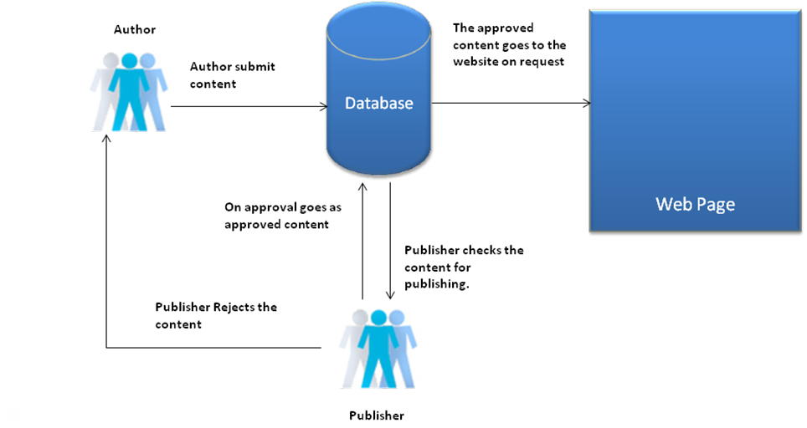

User Interface requirements

Global components
The site will have some common features and can be classified as global components:
Following are the global component

Disclaimer: The images shown below to represent the various components/parts of the website are as per the wire frames created earlier. The images will be replaced by the approved wire frames by around first week of March.

- Site Header: The header section will have all the global navigation menu , search , site map and contact us links

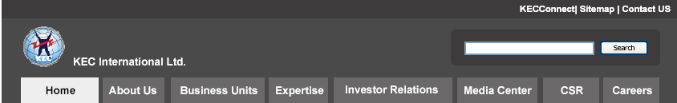

- Site Footer: The footer section will have easy access to the primary and secondary links and the copyright information

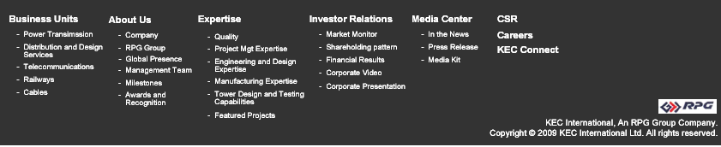

Following sub sections describe different pages that will be part of KEC web site.

Home page
This is the access point for all the users; the layout will be four column layout.

Home page will have a flash banner with the carousel effect. Home page will display the market status. Home page will have easy links for Download Brochures, Corporate videos and corporate presentation.

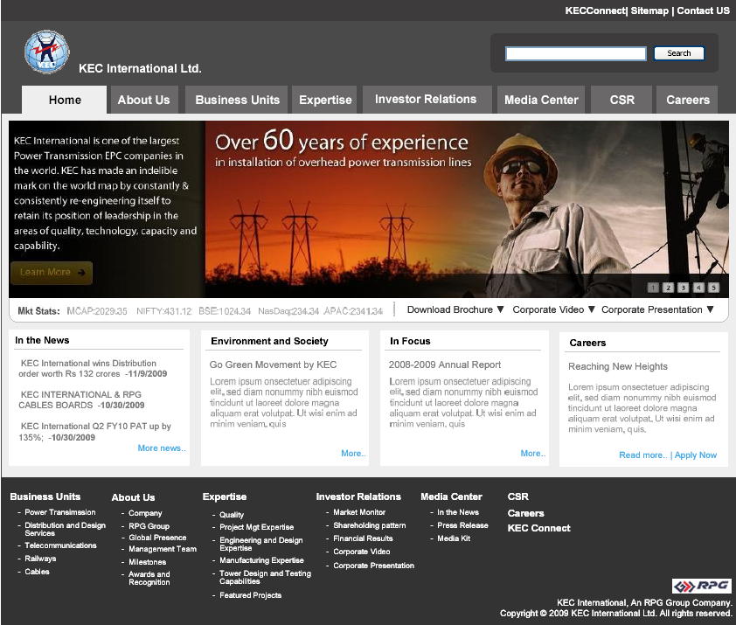

About us
This section will have following submenus, the submenus will be displayed below the currently - i.e. about us - selected menu and will be displayed horizontally.

Company
The page will contain information about KEC International Ltd. and will have carousel menu which will display the clients of KEC International Ltd. A separate place holder for the major clients will also be there

The Key messages that KEC want to highlight is:

- We are young and energetic. We have experience and expertise in working in difficult situation and terrain and have done plenty of projects successfully.
- We have the size and strength to execute,
- We have high-tech Design capabilities, testing capabilities of 1200 KVA tower, and have strong project management capabilities.

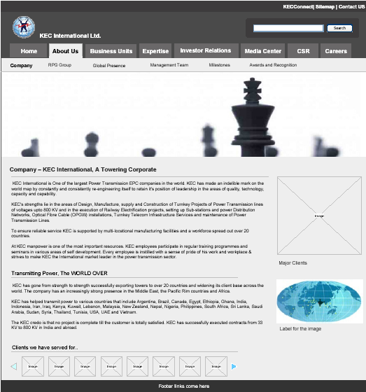

RPG Group
This page will display all the company under RPG Groups
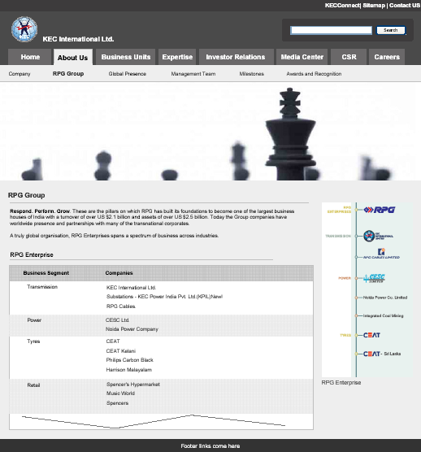

Global Presence
This page will display location of all the KEC International Ltd. branches globally. A map will be used to represent the locations; map can also be filtered continent wise
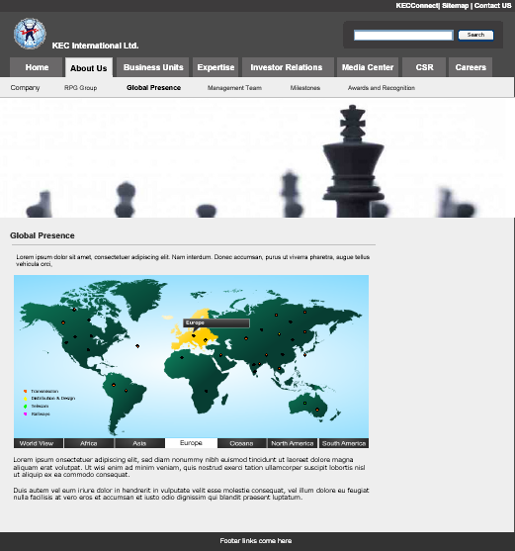

Management Team
This page will list down the management team with the photo, name and individuals designation. On clicking the particular image the details will be displayed in a light box with the individual’s complete profile.
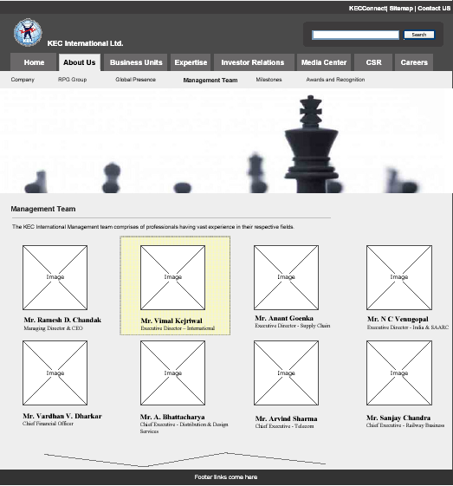
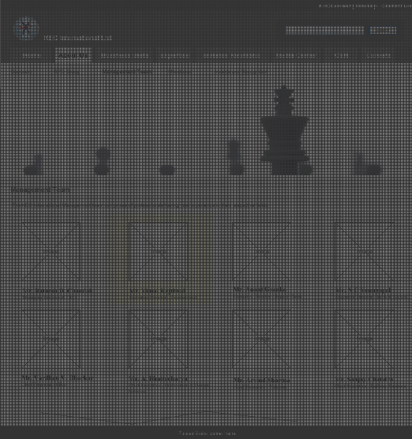

Milestone
The page will display the KEC International Ltd. milestone achievements
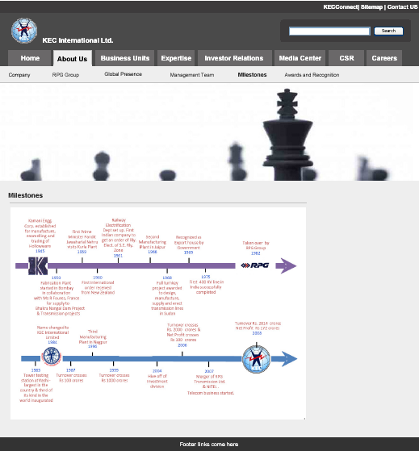

Awards and Recognition
This page will highlight the awards and recognition received by KEC International Ltd.
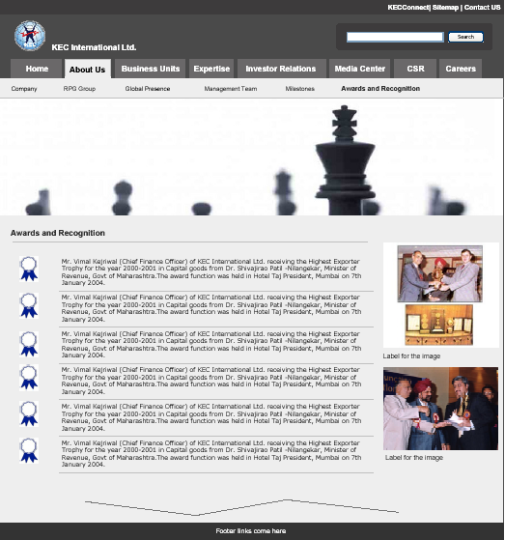

Business Unit

Power Transmission
This page will display information about KEC International Ltd. power transmission unit
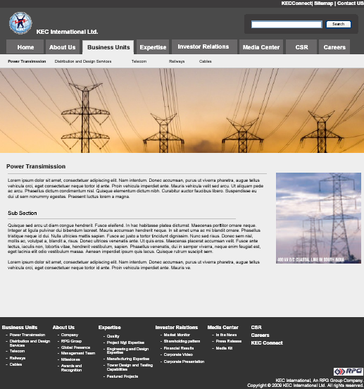

Distribution and Design Services
This page will display information about KEC International Ltd. distribution and Design Services unit

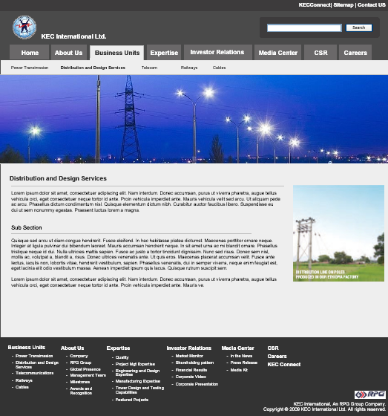

Telecommunications
Wireframes not yet finalized

Railways
This page will display information about KEC International Ltd. railway unit

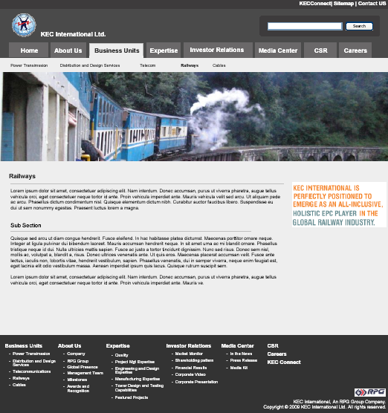

Cables
Wireframes not yet finalized

Expertise
Quality
This page will display information about KEC International Ltd. expertise in the quality and will display all the certificates using carousel menu
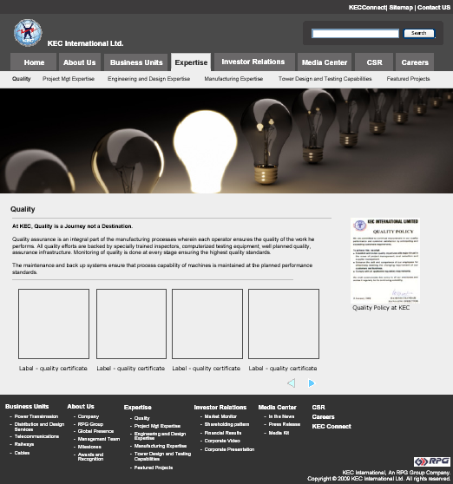

Project Mgt Expertise
Wireframes not yet finalized

Engineering and Design Expertise
Wireframes not yet finalized

Manufacturing Expertise
Wireframes not yet finalized

Tower Design and Testing Capabilities
Wireframes not yet finalized

Featured Projects
This page will display information about KEC International Ltd. projects and clients testimonials.
Project name, country name and the short description with read more will be displayed.
User can view the details of the project when user clicks on the more links provided for individual projects

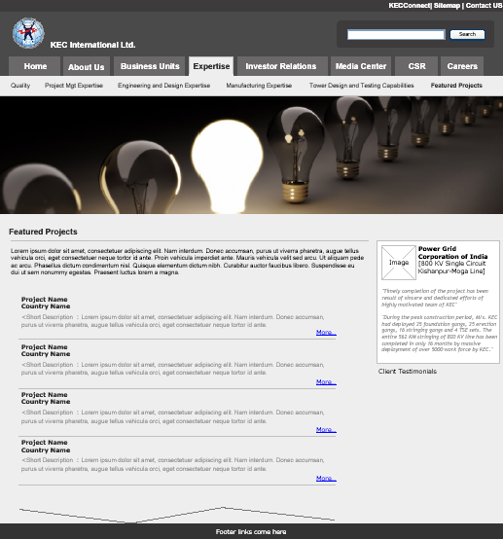
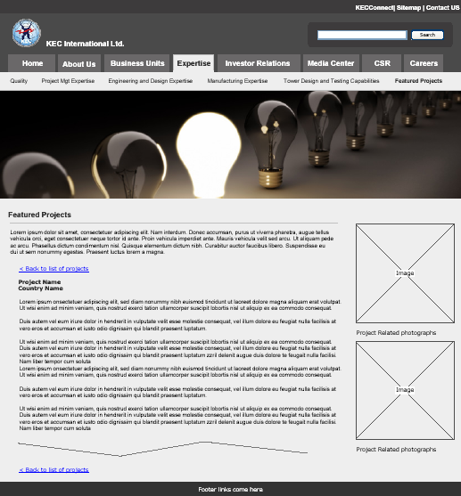

Investor Relation
Corporate Video
This page will display the videos assigned for the player, financial results, shareholding pattern and video download functionality will also be available on this page
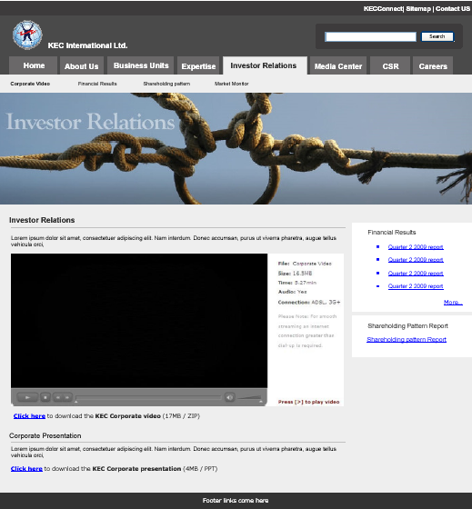

Financial Results
This page will display annual and quarterly financial results using carousel menu. Balance sheet, income statement and download links will also be there.

On clicking the individual reports the detailed balance sheet will be displayed
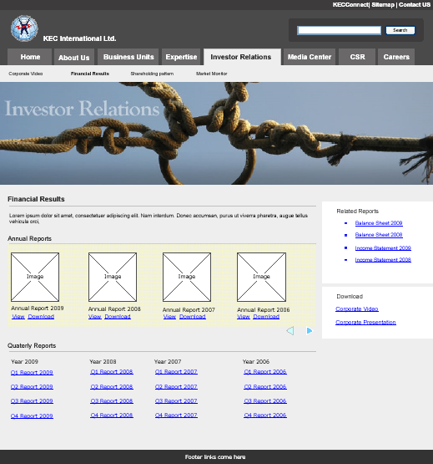

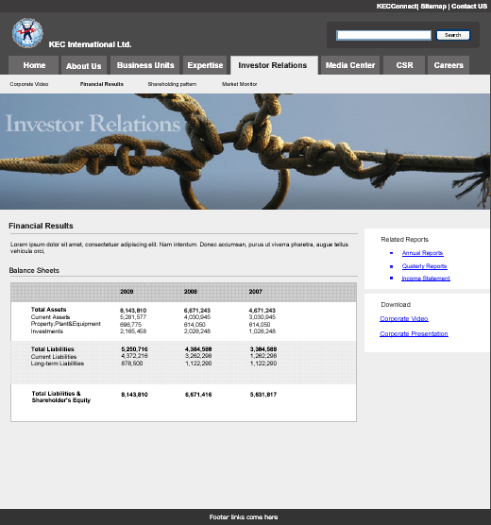
Shareholding pattern
Wireframes not yet finalized

Market Monitor
Wireframes not yet finalized

Media Center
Wireframes not yet finalized

CSR
Wireframes not yet finalized

Careers
This page will display about the career opportunities. User can also apply for jobs, view current openings, download application form or walk in interview form, from this page

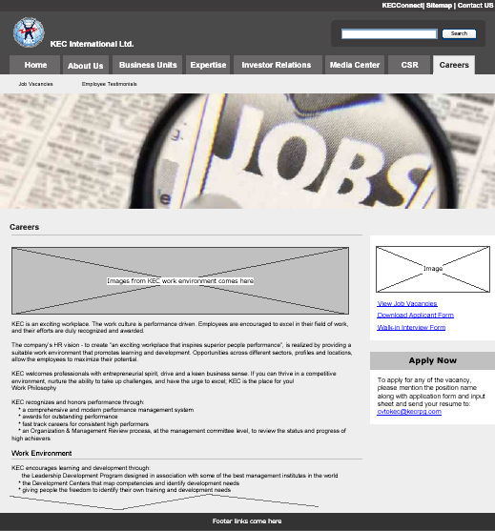

Job Vacancies
This page will display all the job vacancies and user can click on the plus sign to see the details about the job.

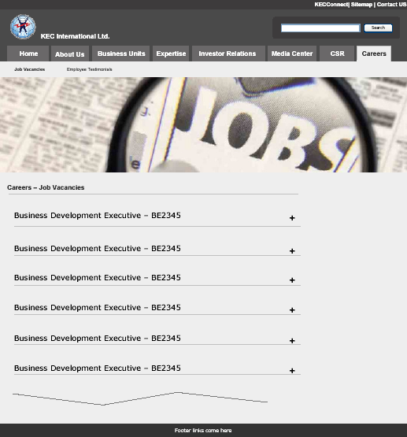

- Job Posting

KEC would be able to post the jobs using a standard template with an Expiry date. Once expiry date is reached the job would be automatically unpublished. Alternatively, job posting can be manually deleted.

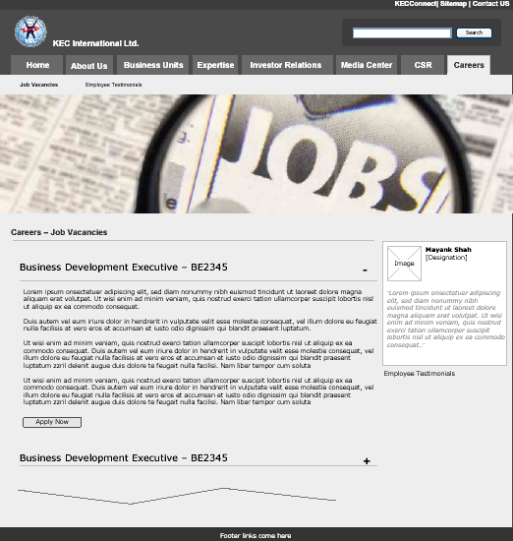

Employee Testimonials
Wireframes not yet finalized

Contact us
This page is 2 column layouts, with contact form and community.

The contact form will have the following fields:
- Select Community
- Full Name
- Email Address
- Phone Number
- Remarks
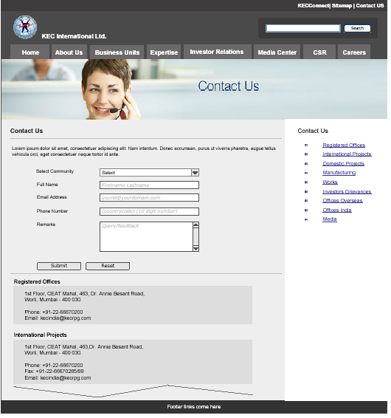

On selecting the contact person from the right link the user will be navigated to the address detail section and the feedback will be sent to the concern group only

Interactive components
- Search

The standard Joomla search will be used unless specified by KEC International Ltd. All published content can be searched using OOTB search features. There is no current requirement for advanced search.

- Job Posting

KEC would be able to post the jobs using a standard template with an Expiry date. Once expiry date is reached the job would be automatically unpublished. Alternatively, job posting can be manually deleted. Jobs will be managed using Joomla administrator interface.

- Resume upload & Job search

Resume will be uploaded using a form; user will be allowed to upload only certain extension (exe, bat etc will not be allowed) and with a size limit (usually 150 Kb)

- Online form to apply for vacancies

User can select a job category and the fill up the details, on submitting the form, email will be generated for the admin of that section.

The Section will be configurable; an authorized person will be able to manage this email id of the group.

- Enquiries/Feedback forms

Enquiries/Feedback forms will be submitted to the email-id provided by KEC International Ltd

Please refer to the contact us section

- Financial Reports

Financial Reports will be managed through article manager; any file associated will be linked using a link tag

- Blog
Standard Joomla Blog plug-in will be used to provide the collaboration features
.

Non-Interactive components
Standard Joomla components will be used to provide the placeholders for following content types.

- About the company
- Service Details
- Financial performance
- News and Events
- Company Stock Prices - component

Company listing will be made available on Home page using standard Web services or API. Zensar would notify KEC International Ltd. in advance, the cost involved in buying the web service or API if needed.

Zensar would use the market ticker on the website used on the current website of KEC International Ltd. KEC to provide the API’s & related information they are using for the Company Stock Price component.

- Corporate governance
- Catalogues/Brochures
- CSR / Environmental policies
- Contact details
- Flash Banner on home page
- Technical Papers
- Client Testimonials
- Current Project details
- Media Page

Non Functional Requirements

Usability Requirements
- Cross Browser: Support for IE6 & 7, Firefox 3 (Windows OS) unless specified by the KEC International Ltd.
- Web Standards: Follow W3C standards.
- Clean and Simple User Interface: Web 2.0 look and feel
- Ease of navigation: Easy to use and user friendly navigations as reviewed and approved by KEC

Guidelines:
- The colour scheme should be soothing and clear. Using heavy corporate shades of Blue/Red are not mandatory for design. As long as the corporate colour shades are coming in logo, it is fine.
- The website should highlight “Experienced” and “Youth” personality to its face.
- To portray that it’s a global company, the use of GLOBE is not mandatory.
- The basic expectation from the site is, it should be user friendly and should be very fast to load.
- SBUs should be clearly visible from the home page and coming audience can be directed easily to respective sections
- There may be a ticker to reflect the happenings.
- The messages in the design are to be very prominent and crisp
- No cryptic language or ‘thematic representations’ required. Target Audience understands direct language and the messages on the homepage should convey that
- No marketing flavour.
- Images are to be used from the existing repository of KEC. No outside/downloaded image is to be used.

Security and Control Requirements
Only administrator will be able to moderate the content, a login page will be provided for him and on authentication the admin will have full control, otherwise everything else including documents will be publicly available.

Performance requirements

Following are the proposed response times assuming the below mentioned server configuration & bandwidth. Any changes in the configuration may have impact on the performance mentioned.

Page Size: Assuming the size of 350 - 450 Kb
User Environment:
Case-1) For 256 kbps
User downloads speed: 40 kbps
8-9 seconds for first time
4-6 seconds subsequent visits
Case-2) For 512 kbps
User downloads speed: 70kbps
4-6 seconds first time
2-4 seconds subsequent visits
Server Environment:
Bandwidth: 2 Mbps
Processor: Intel Xeon @ 3.00 GHz x 2
RAM: 8 GB DDR2 SD RAM (1GB x 8)
In addition to performance testing Load testing will also be done for concurrent 100 Users on the website.

Availability and Reliability Requirements

- Availability of the website should be managed by the hosting service provider.
- Security of the website is managed by hosting provider

KEC is looking for new service provider. Netmagic evaluated. KEC is expecting a proposal for the hosting services from Zensar.

Project Methodology
Zensar will follow the following methodology in developing the system
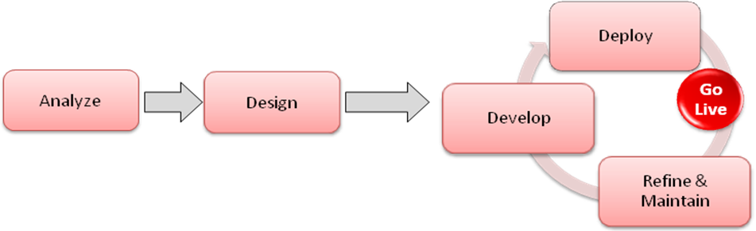
The phases of the project will be as stated below

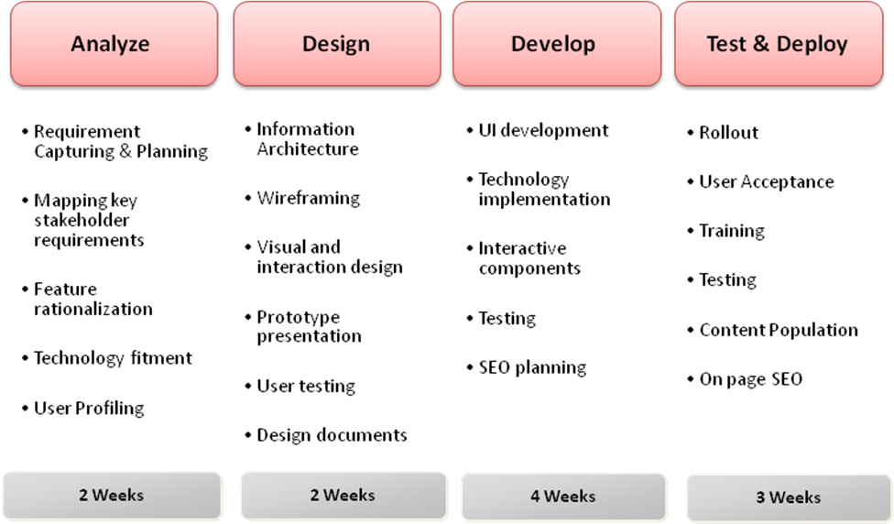

Hardware Environment
The current KEC website is hosted at Reliance Data centre with the following configuration

- Server type
Dedicated server for RPG
- Operating system
Windows 2000
- RAM
512 MB
- Disk Space
C: 5 GB (system files)
D: 6 GB (Out of which utilized is 250 MB for KEC)
E: 34 GB (not used by KEC), used for backup
- Web server
IIS Web server
- Database
SQL 2000 server
- Bandwidth
50 GB data transfer / month – shared for 3 websites

KEC is looking for a new service provider; accordingly the hardware configuration may vary

Software Environment
The software requirements are as:
- PHP (latest stable release)
- MYSQL (latest stable release)
- APACHE (latest stable release)
- JOOMLA (latest stable release)
- Window Operating System

Maintenance and Support requirements

Zensar provides free support during development and provides warranty on the delivered solution.
- The Warranty Period with respect to the deliverable will be 45 days from the date of Acceptance.
- During the Warranty Period with respect to the deliverables, Zensar warrants that, under normal use on the hardware for which it was designed and without unauthorized modification, the software / deliverables will perform substantially in accordance with the specifications specified.
- Zensar will provide warranty support from its offshore premises.
- The warranty support will cover the rectification of any bugs within the accepted SRS document during the usage of the system. Warranty maintenance shall not extend to any user defined modification requirements, functional requirements, feature changes, or performance enhancements.
- Zensar will provide basic training which includes Joomla CMS to the KEC IT team during the warranty period for smooth handover of the system.

